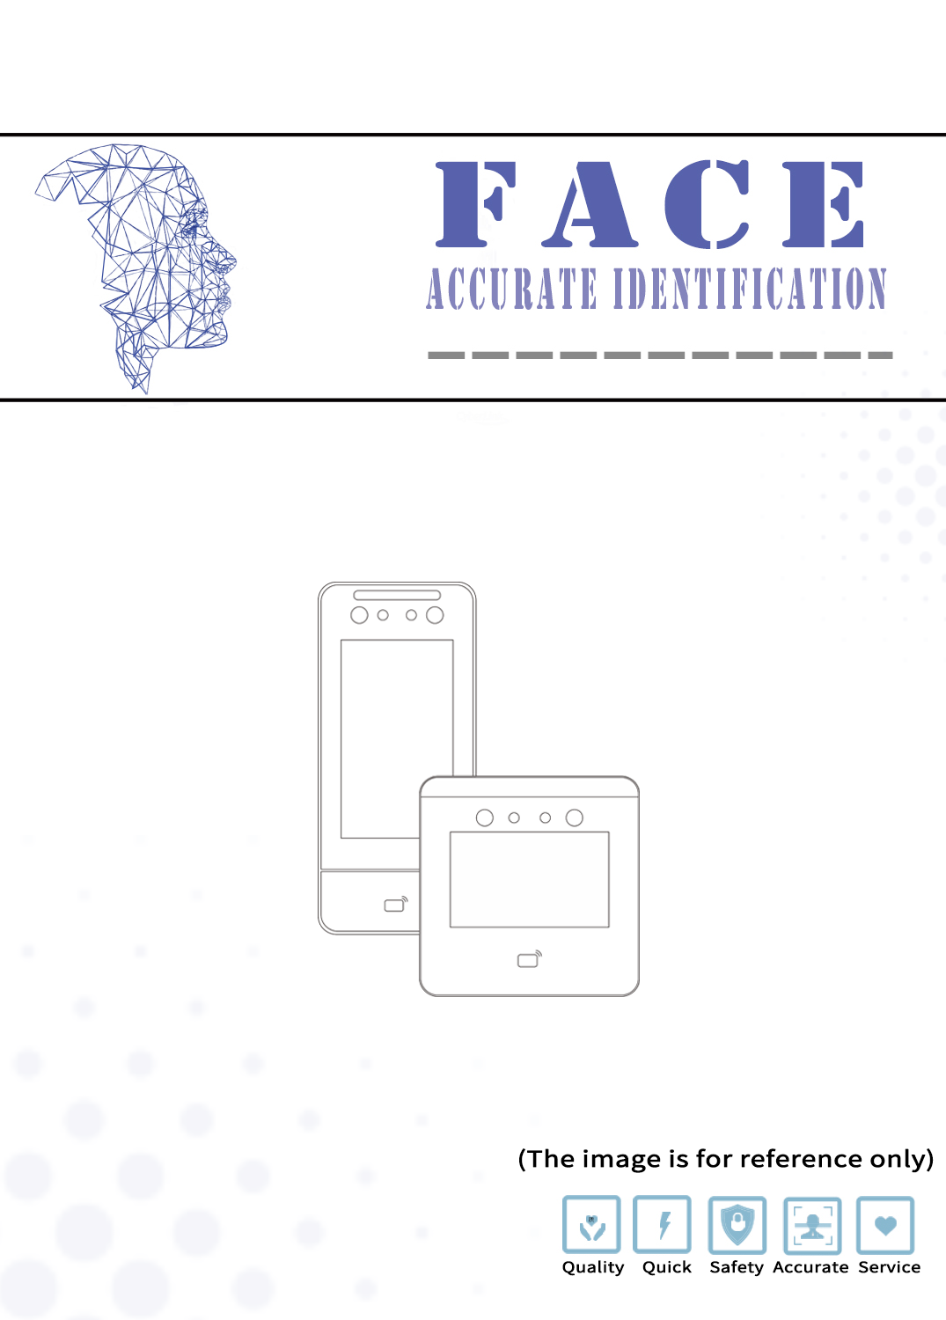

Device Usage
1. Entering the Menu
Click the menu icon in the lower right corner of the standby interface to directly enter the menu page (Figure 2). If an administrator is set, administrator verification is required to enter.
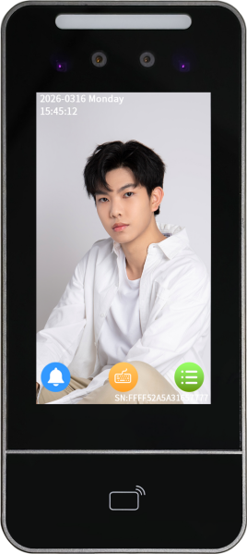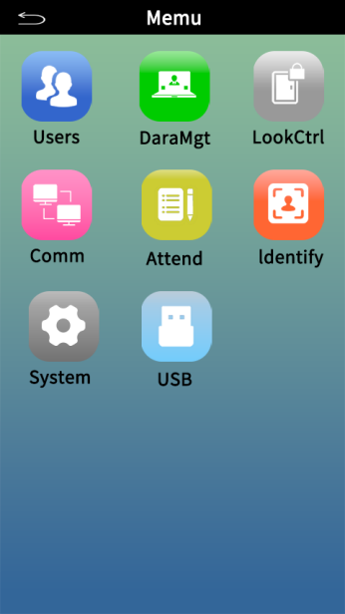
Figure 1 Figure 2
2. User Management

1. Register User
Click 【User Management】→【Register User】 to enter (Figure 3).
Number: Purely numeric, maximum of 8 digits, it is recommended to keep the default order without modification.
Name: Custom input
Photo: After entering the employee number and name, click the image box to register the user's face (Please face the camera directly during registration and hold until prompted that the entry is successful. If the entry is unclear, you can click the image box again to re-enter).
Password: Click the password box to enter the user password, with a maximum of 6 digits.
Card Number: Click on the card number section, and after swiping the corresponding card, the card number will be automatically filled in, or you can enter your phone number as the card number.
Department: Click on the department option to select the corresponding department. It will default to empty. For department settings, please return to the previous menu and set it in the department settings, refer to 3.
After registration is complete, click save to finish user registration.

2. Modify User / User Preview
Click 【User Management】→【User Preview】 to enter the user list. Click on a user's information to modify the corresponding registration (Figure 4). Refer to the user registration for modification operations. In the permissions section, you can modify the user's permission role. If you select Administrator, you must verify as an administrator to enter the login menu.
User Search: On the user list page, click the “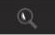 ” at the top of the screen (Figure 5), then click the blank box to enter the employee number or name for precise searching.
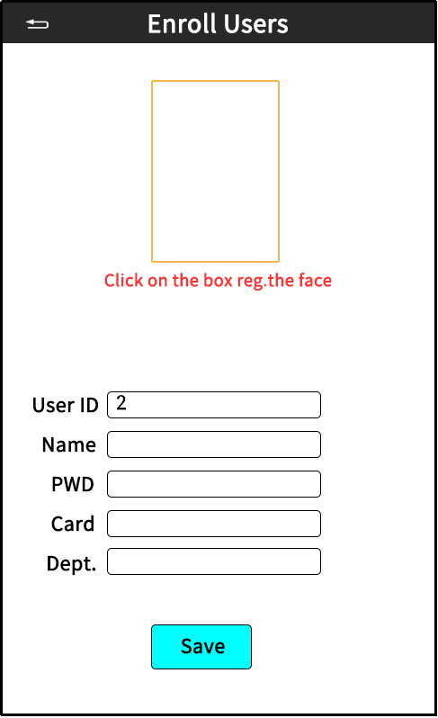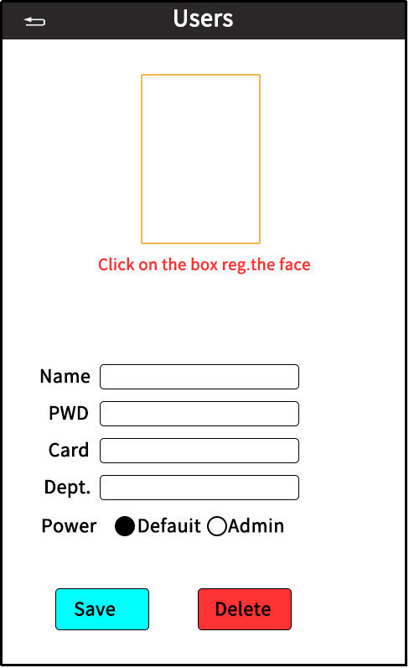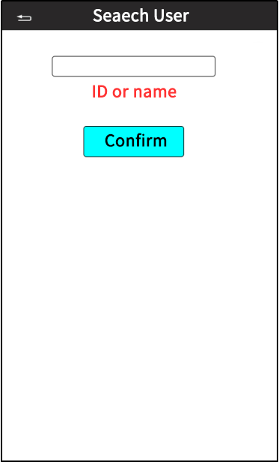
Figure 3 Figure 4 Figure 5
3. Department Settings
The department settings are mainly used for attendance reports, with a maximum of 20 departments that can be set. Click to modify the corresponding department name based on the listed department list.
3. Data Management
Click on Data Management to view and manage various data from the devices, as shown in the figure:
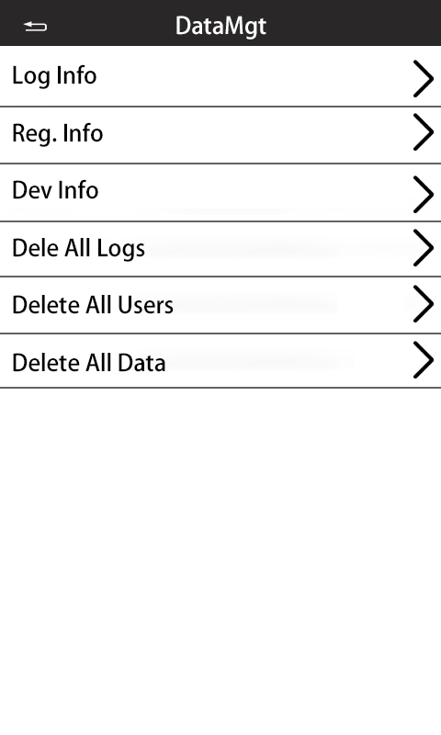
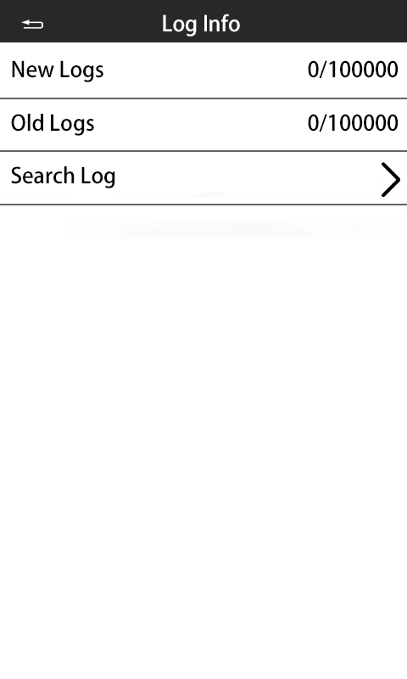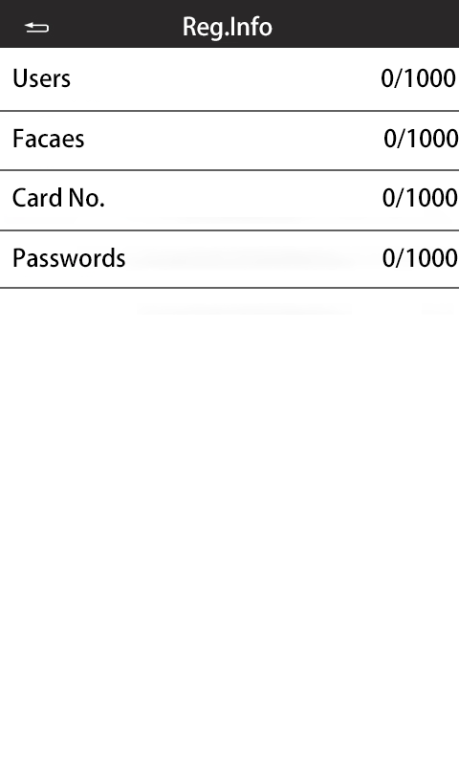
4. Access Control Settings
Click on [Access Control Settings] to enter the page shown in the figure below (Figure 6).
Enable Button: The enablement of the door opening button; if canceled, the door opening button will short-circuit and not drive the door opening signal.
Door Closing Delay: After swiping the card to open the door, there will be a delay time, meaning the door will relock 3 seconds after swiping the card. The delay can be set from 0 to 255 seconds.
Door Entry/Exit Selection: Entry/Exit
Wiegand Settings: As shown in Figure 7, the settings for the Wiegand output signal. Wiegand mode can be selected as 26/34, input format can be selected as card number/ID number. The Wiegand signal can only be output normally after enabling the output, and the output format can be selected as card number/ID number.
Timed Door Opening Settings: Weekly cycle, settings can be made from Monday to Sunday. Each day can have 3 time slots, and settings can be made for always open, always closed, or online mode within the time slots.
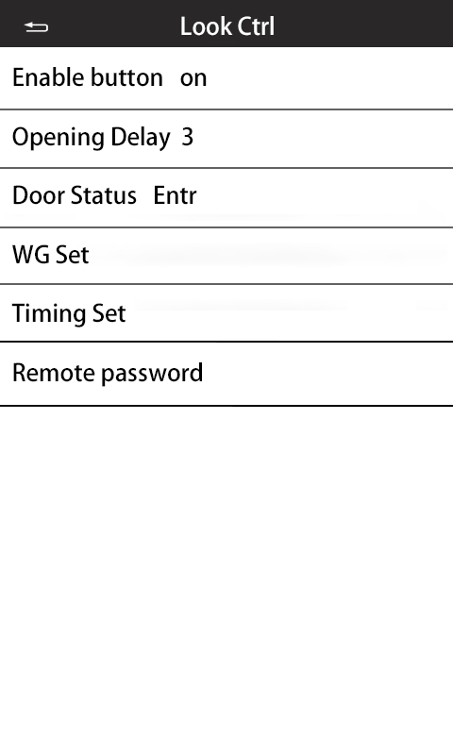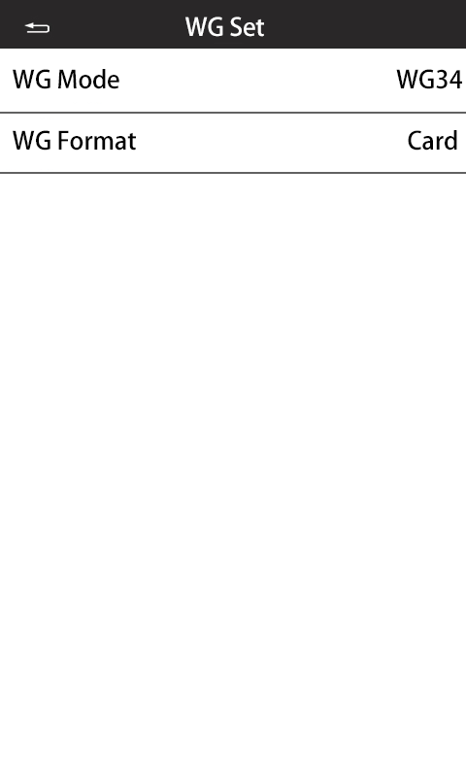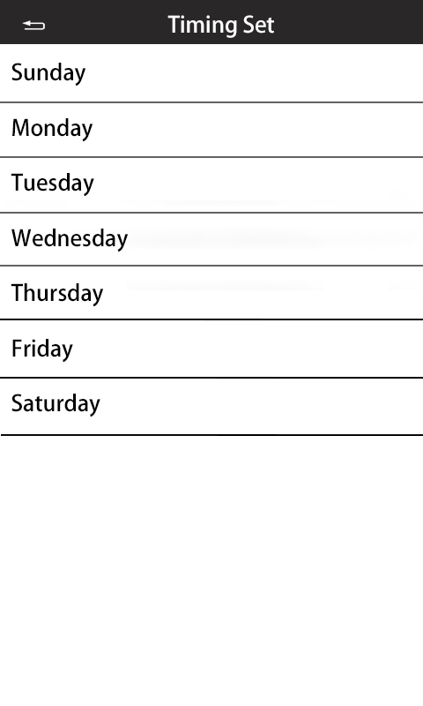
Figure 6 Figure 7 Figure 8
V. Communication Settings
Click on the menu page [Communication Settings], as shown in Figure 9:
Connection Method: Wired/WIFI. For wireless non-standard products, please confirm if the model supports WIFI connection.
Local Network: As shown in Figure 10, wired network configuration. Enable DHCP for the router to automatically assign IP addresses. It must be connected to a router or switch with DHCP functionality to work properly. If DHCP is not enabled, you can freely set the IP address, subnet, and gateway, but they must match the local network to connect properly. Communication password is empty by default and can be configured on the device or software. After setting, you need to enter the communication password to search and communicate.
WIFI Settings: Only models with WIFI functionality can be configured. Select WIFI to enable it, then search for wireless networks. Click on the found WIFI and enter the password to connect.
Cloud Configuration: Only cloud models can be configured.
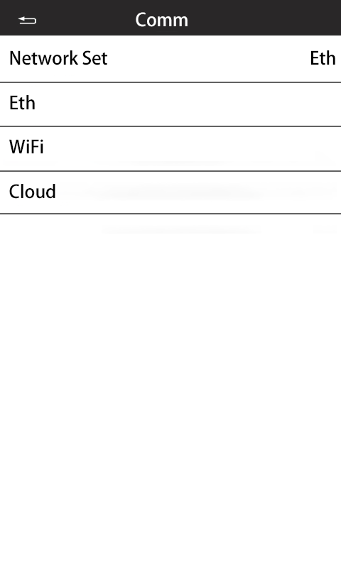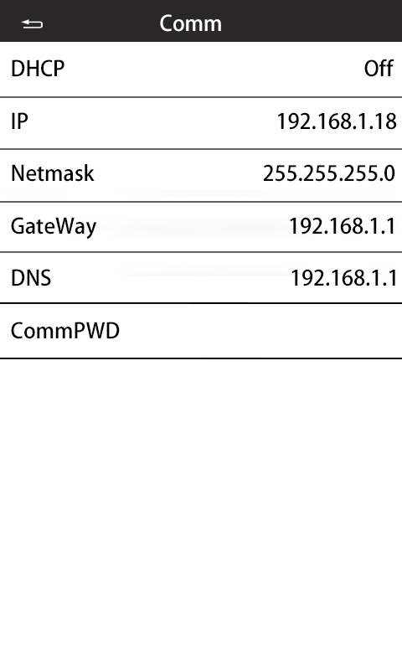
Figure 9 Figure 10
VI. Attendance Management
Click on the menu page [Attendance Management] to enter the attendance settings page, as shown in Figure 11.
Shift Settings: As shown in Figure 12, set the shifts for employees, with a maximum of 12 shifts. The shift time is divided into three segments: two segments for regular working hours and one segment for overtime. If only one segment is used for regular working hours, then only one segment for clocking in and out needs to be set. The system defaults to Shift 1 for employees. If other shifts need to be modified, they can be downloaded via a USB drive, modified on a computer, and then uploaded back to the machine.
Attendance Rules: As shown in Figure 13, the allowed time range for tardiness and early leave.
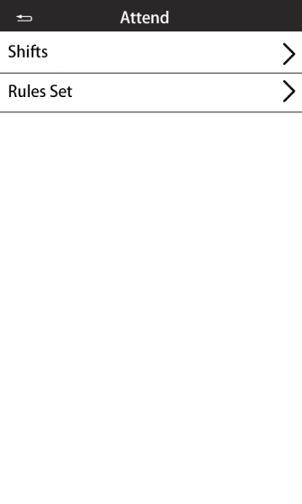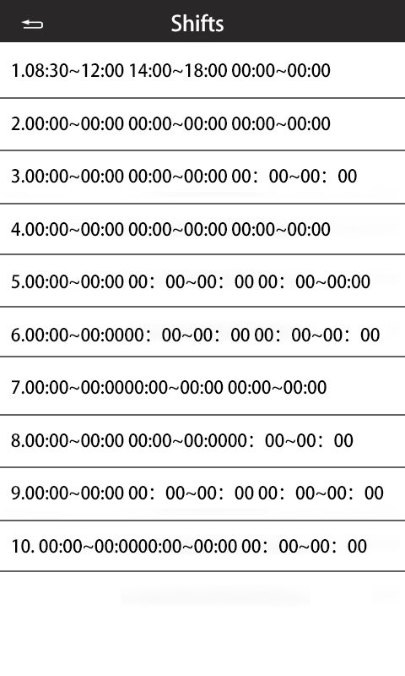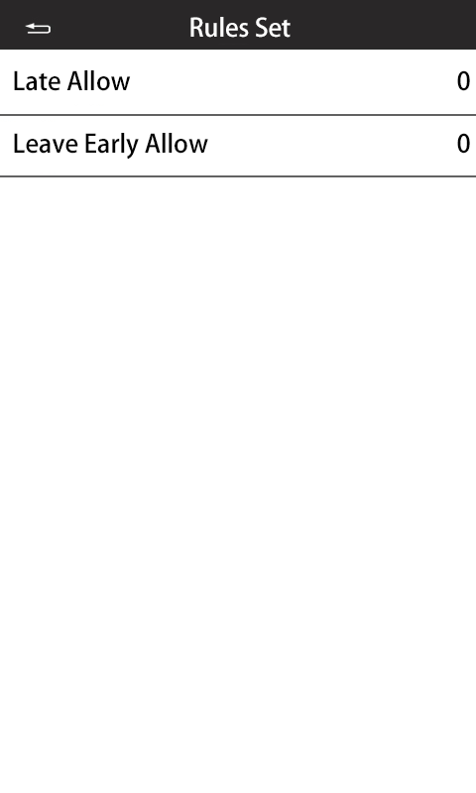
Figure 10 Figure 11 Figure 12

7. Recognition Settings
Click the menu [Recognition Settings] to enter the parameter settings page, where various recognition parameters can be set, as shown in Figure 13.
Recognition Score: The default value is 5, adjustable from 0 to 60. The higher the value, the greater the security, but the difficulty of recognition will also increase.
Live Body Switch: Off/Weak Live Body/Strong Live Body. Selecting "Off" disables live body detection, allowing photos to be recognized directly.
Supplementary Light: The activation methods include Normally Closed/Automatic/Timed/Normally Open. Normally Closed means the supplementary light will not turn on at any time; Automatic means that in low light conditions, the supplementary light will automatically turn on during face recognition, or it will turn on during normal face recognition; Timed means the supplementary light will stay on during set time periods, with three time slots available; Normally Open means the supplementary light will stay on all day.
Stranger Record: Off/On. When turned on, stranger recognition will save records.
Stranger Door Access: Off/On. When turned on, registration is not required; the door will open directly with a card swipe or face recognition.
Identification distance: Far/Mid/Near.
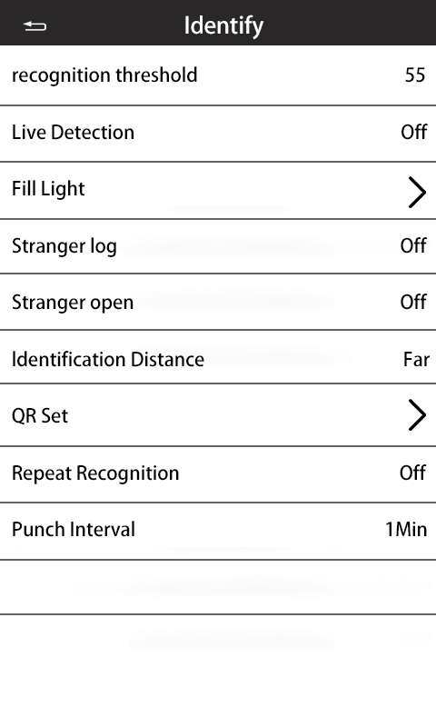
Figure 13
Re-confirmation time: Default 1 minute, which means if the same user is recognized continuously within one minute, only the earliest recognition record will be saved.
VIII. System Settings
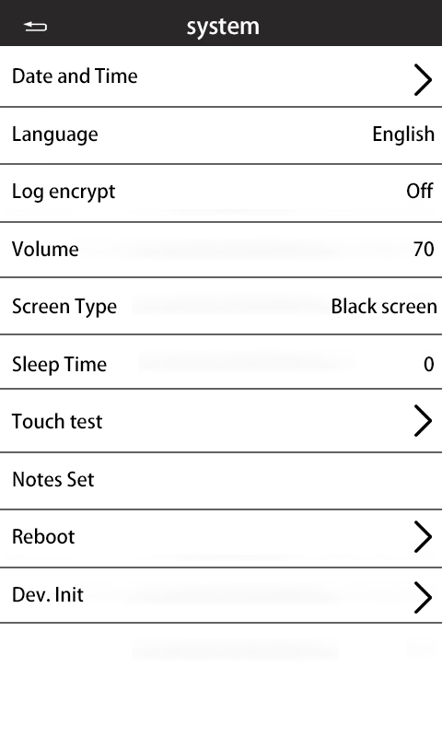
Click on the menu page [System Settings] to set various parameters of the system, as shown in Figure 14.
Time settings: Set to adjust the machine's time, models with network connectivity can also synchronize through software.
Language settings: Chinese and English can be switched.
Volume settings: 1 - 100 can be set.
Screen saver type: Screen off.
Screen saver time: This refers to how long the system waits before switching to the screen saver (turning off the screen). The default is 60 seconds, and it can be set from 0 to 600 seconds. Setting it to 0 will disable the screen saver.
Touch Test: Check the use of the touchscreen.
Note Settings: The text displayed at the top of the device's standby interface can be customized, with a maximum of 16 characters.
Device Restart: Restart the machine.
Device Initialization/Factory Reset: Restore the machine to factory settings, including clearing user data, records, and set parameters. Please use with caution.

9. USB Function
Click on the menu page [USB Function] to upload and download various data from the machine, as shown in Figure 15.
Photo Import: Use photos to quickly register user faces in bulk. Steps: Create a folder named User in the root directory of the USB drive (FAT32 format), then create a folder named Photo inside User, and place images (JPG format, under 300K) in the Photo folder. Then operate the machine to import the photos.
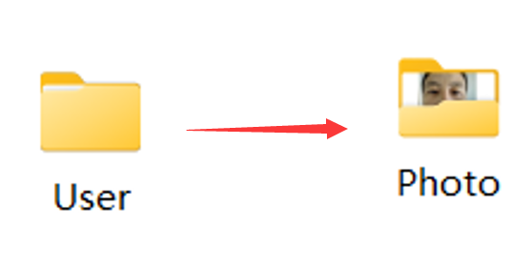
Download Personnel: Download personnel data from the machine to the USB drive. Insert the USB drive, click on Download Personnel in the USB function menu, and a User folder will be generated in the USB drive upon success. This folder contains two files: one is the Photo folder with the downloaded personnel photos, and the other is a .dat file with personnel information for software import.
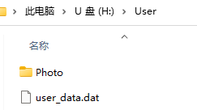
Upload Personnel: Personnel can be entered on one machine, downloaded to the USB drive, and then uploaded to other machines via the USB drive.
Download Personnel Information:
Upload personnel information:
Download records: Download clock-in records to the USB drive, which can be imported into the software to view specific record information. After downloading, there will be a folder named Record in the USB drive, which contains the machine's serial number folder.
Download shifts: Download attendance shifts. After downloading, an attendance settings.xlsx Excel file will appear in the USB drive. Opening it will reveal two sheets: attendance settings and scheduling settings. The attendance settings contain shift times, which can be modified, while the scheduling settings contain each employee's shift schedule, which can be modified individually or in bulk.
Upload shifts: Upload the modified shift schedule to the machine.
Download reports: Download employees' attendance reports. After downloading, a monthly summary sheet will appear in the USB drive, such as the September summary.xls. This Excel file contains five types of tables:
Summary table: This table summarizes and calculates employees' attendance information for each month, including late arrivals, early departures, and absences;
Scheduling information: This table shows employees' scheduling information for each month, allowing for comparison with data from other reports;
Exception statistics table: This table records each employee's daily exception data, such as late arrivals and early departures;
Card swipe records: This mainly records detailed clock-in records of employees;
1, 2, 3…: Card-style reports, one for each employee, recording detailed attendance clock-in records.
Firmware Upgrade (Upgrade Firmware): Used for upgrading firmware.

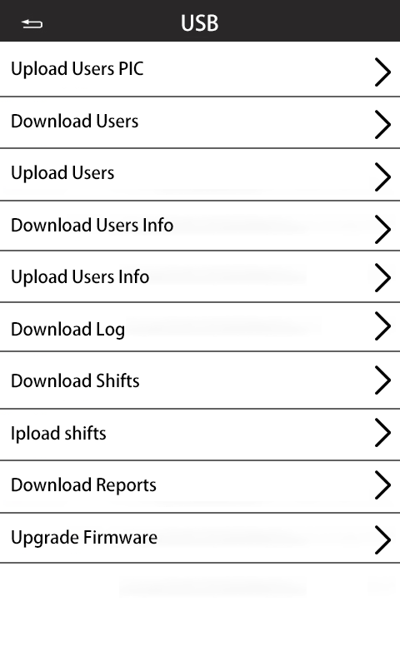
Figure 15

Note: The above equipment function menu is for explanation only; the specific functions are subject to the device display.
SizeFigure

Dimensions of the 4-inch and 5-inch face wall-mounted bracket (there may be some errors; please refer to the actual product for specifics)
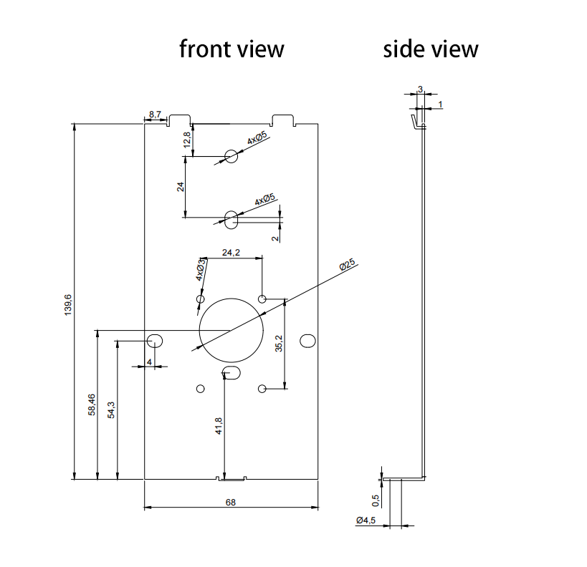

Installation NotesItems
Installation Height
The device should be installed in a position that avoids backlight, side light, and direct strong light as much as possible.
It is recommended to install at a height of approximately 1.4m (the distance from the lens to the ground). At this height, the recognizable height range at a distance of 0.5m from the device is 1.3m to 1.7m; at a distance of 1m, the recognizable height range is 1m to 2m (with some deviation). The installation height can also be adjusted based on actual usage.
To ensure quick and accurate certification, it is best for personnel to be 0.4m away from the device (within a range of 0.3 to 0.5m), and the registered facial photo should have a pixel count of no less than 100 pixels. The facial illumination intensity (referred to as illuminance) detected by the device should not be lower than 30Lux. The device is equipped with a supplementary light; in environments with weak lighting, the facial illumination intensity at a distance of 0.5m from the device is approximately 100Lux, and the closer the face is to the device, the higher the facial illumination intensity. If the facial exposure is too high, it may lead to difficulty in extracting feature points and recognition.
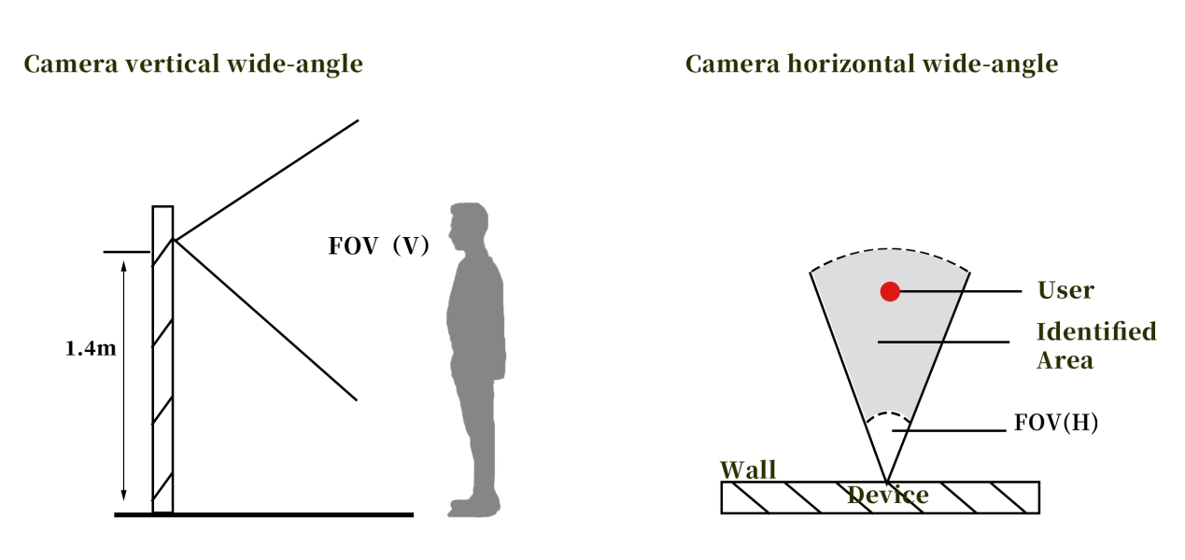

Installation Steps
Drill 3 screw holes at a suitable position on the wall according to the bracket specifications. If it is a hard base wall, please use the expansion screws from the accessory package. Then align the three holes on the bracket with the holes drilled in the wall, and use the screws from the accessory package to secure the bracket to the wall. Before fixing the bracket, please pass the wiring through the outlet of the bracket or lead it out from the side of the device. As shown in the figure below:
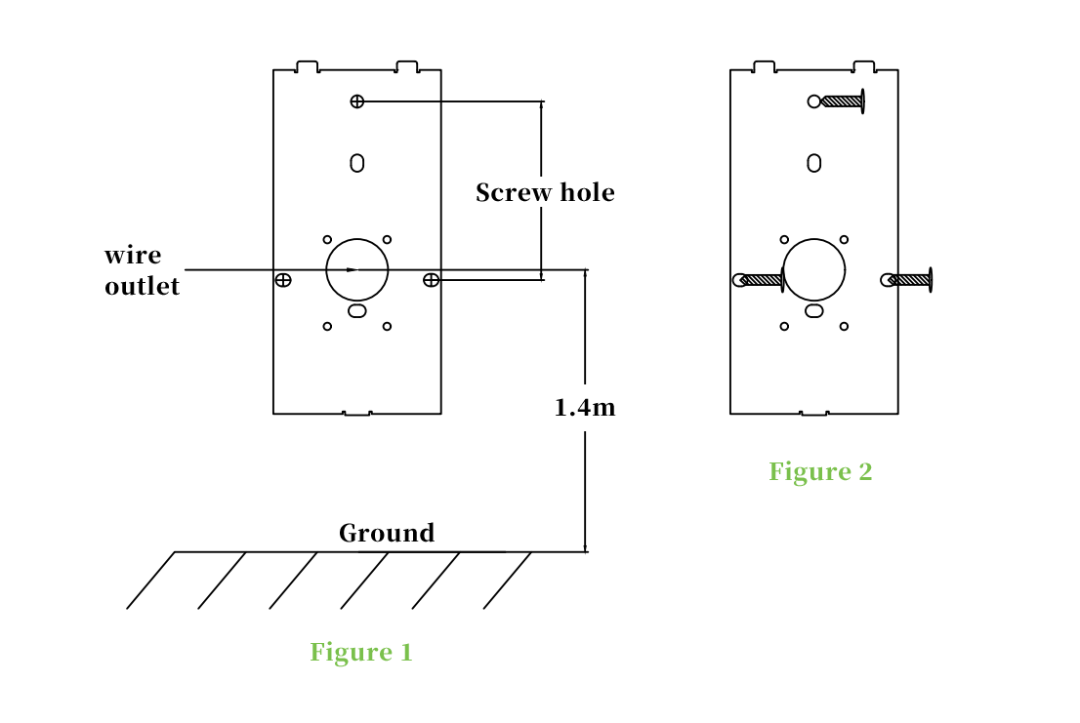
Then, align the bracket with the groove of the facial recognition device and tighten it. The bottom of the bracket should align with the screw hole at the bottom of the facial recognition device, and use screws to tighten it clockwise to complete the installation.
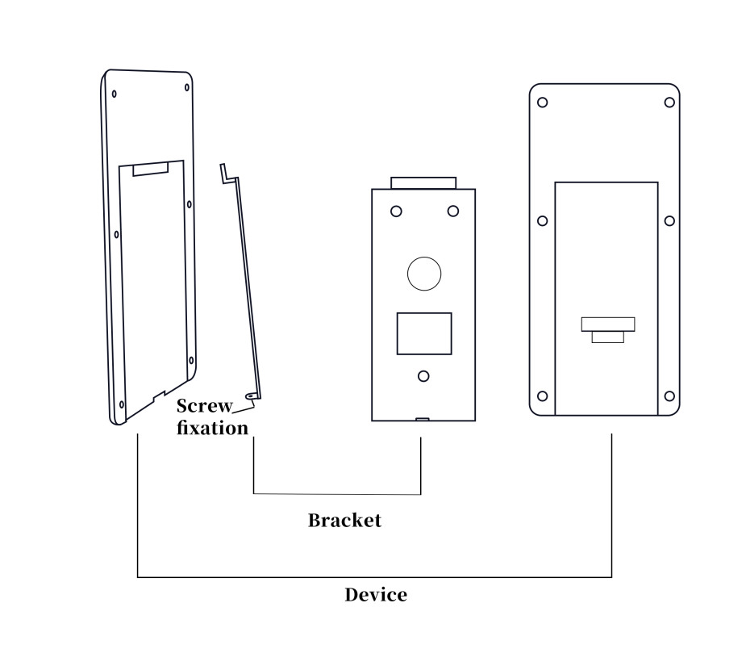

Installation Precautions:
1. Try to install the device in a location with minimal influence from light sources.
2. Adjust the recognition threshold appropriately based on usage to improve recognition effectiveness.
3. The actual wiring needs to select appropriate cables based on the distance to ensure the normal power supply voltage of the equipment.

Equipment Wiring
Wiring diagram for facial recognition access control:
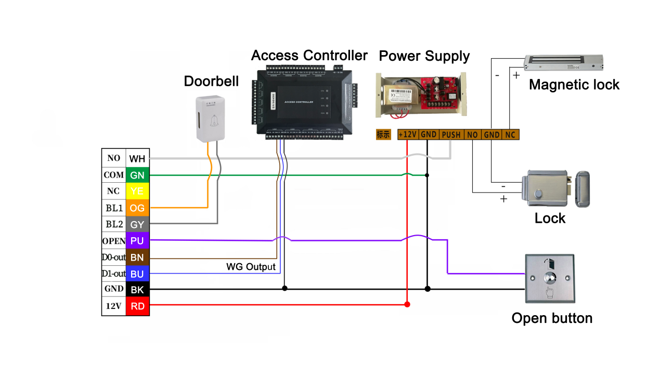

Power line: Use a two-core wire with a diameter of more than 1.0 mm to ensure the terminal voltage is >11V.
Door button wire: Use a two-core wire with a diameter of more than 0.5 mm.
Electric lock wire: It is recommended to use a two-core power line with a diameter of more than 1.0 mm. If the distance exceeds 50 meters, consider using a thicker wire or multiple strands in parallel. The maximum length should not exceed 80 meters, generally controlled within 50 meters.
Doorbell: Use a two-core wire without distinguishing positive and negative. If the doorbell control wire does not indicate positive and negative, please test the output in both directions to ensure it is normal.
TCP/IP communication: Use national standard network cables, and the distance from the controller to the switch or computer should not exceed 80 meters.

Inspector:
Production Date: QC PASS
Certificate of Conformity

Reserved for backup
Version: 1.0
Date: April 2026

